Worksheet 3.3

Student Name: Sahil Kaundal UID: 21BCS8197

Branch: CSE (Lateral Entry) Section/Group:20BCS-807_B Semester: 4th Date of Performance: 02/05/2022

Subject Name: Programming in Python Lab Subject Code: 20CSP-259

1. Aim/Overview of the practical:

* Write a Python program to generate 26 text files named A.txt, B.txt, and so on up to Z.txt.
* Write a Python program to create a file where all letters of English alphabet are listed by specified number of letters on each line.
* Write a Python program to read a random line from a file.
* Write a Python program to count the frequency of words in a file.
* Write a Python program to copy the contents of a file to another file.

1. Task to be done/ Which logistics used:



* Write a Python program to generate 26 text files named A.txt, B.txt, and so on up to Z.txt.

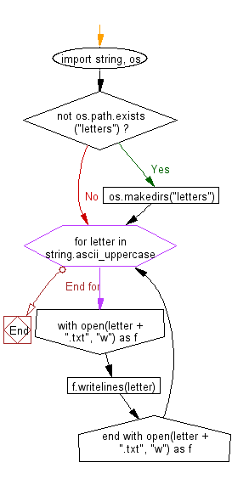

* Write a Python program to create a file where all letters of English alphabet are listed by specified number of letters on each line.

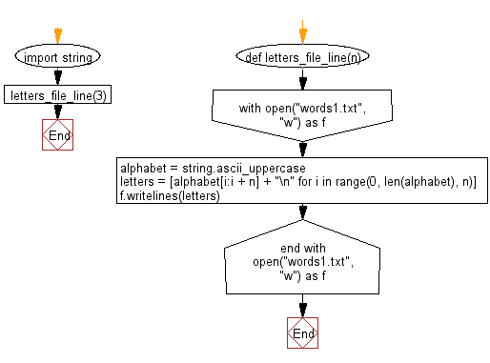

* Write a Python program to read a random line from a file.

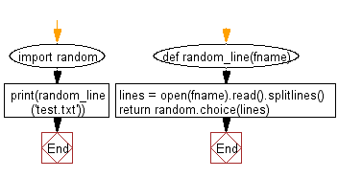

* Write a Python program to count the frequency of words in a file.

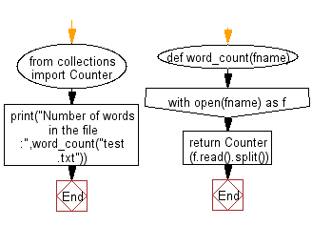

* Write a Python program to copy the contents of a file to another file.

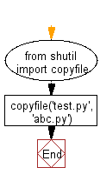

1. Steps for experiment/practical/Code:

* Write a Python program to generate 26 text files named A.txt, B.txt, and so on up to Z.txt.

import string, os

if not os.path.exists("letters"):

  os.makedirs("letters")

for letter in string.ascii_uppercase:

  with open(letter + ".txt", "w") as f:

    f.writelines(letter)

* Write a Python program to create a file where all letters of English alphabet are listed by specified number of letters on each line.

import string

def letters_file_line(n):

  with open("Sahil.txt", "w") as f:

    alphabet = string.ascii_uppercase

    letters = [alphabet[i:i + n] + "\n" for i in range(0, len(alphabet), n)]

    f.writelines(letters)

letters_file_line(1)

* Write a Python program to read a random line from a file.

import random

def random_line(fname):

  lines = open(fname).read().splitlines()

  return random.choice(lines)

print(random_line('Sahil.txt'))

* Write a Python program to count the frequency of words in a file.

from collections import Counter

def word_count(fname):

    with open(fname) as f:

        return Counter(f.read().split())

print("Number of words in the file :",word_count("Sahil.txt"))

* Write a Python program to copy the contents of a file to another file.

with open('Sahil.txt','r') as firstfile, open('second.txt','a') as secondfile:

  # read content from first file

  for line in firstfile:

       # append content to second file

       secondfile.write(line)

1. Result/Output/Writing Summary:

* Write a Python program to generate 26 text files named A.txt, B.txt, and so on up to Z.txt.

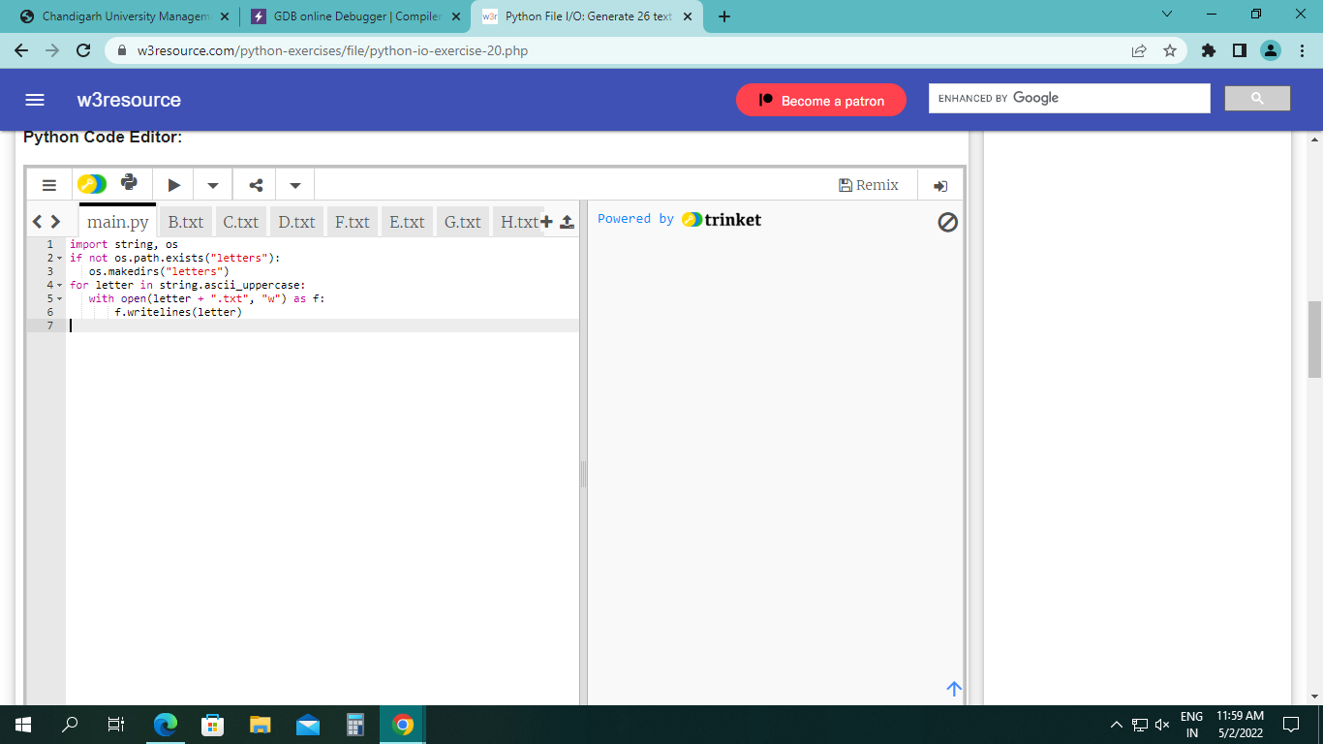

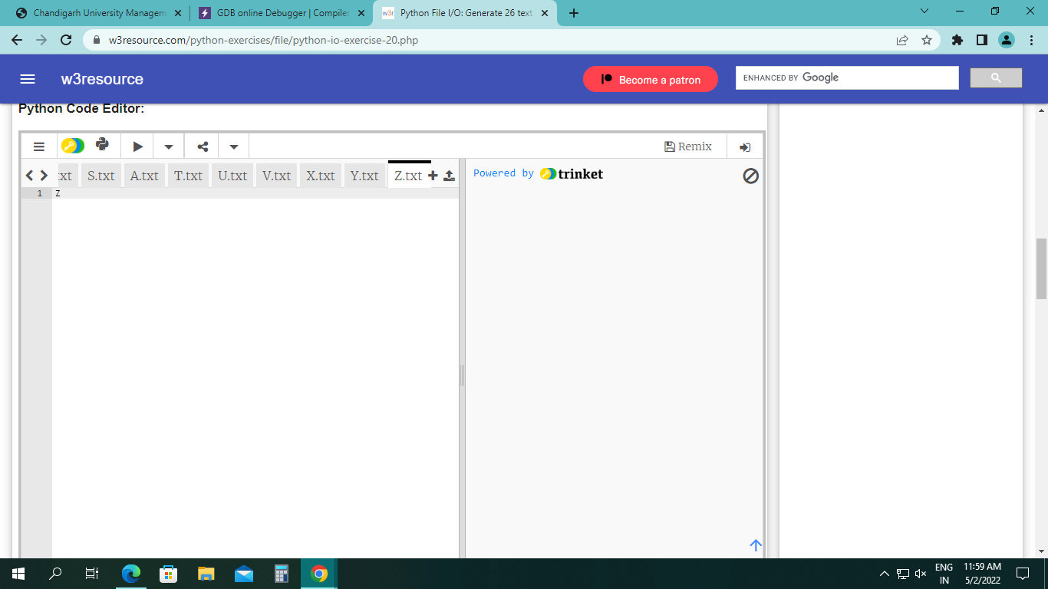

* Write a Python program to create a file where all letters of English alphabet are listed by specified number of letters on each line.

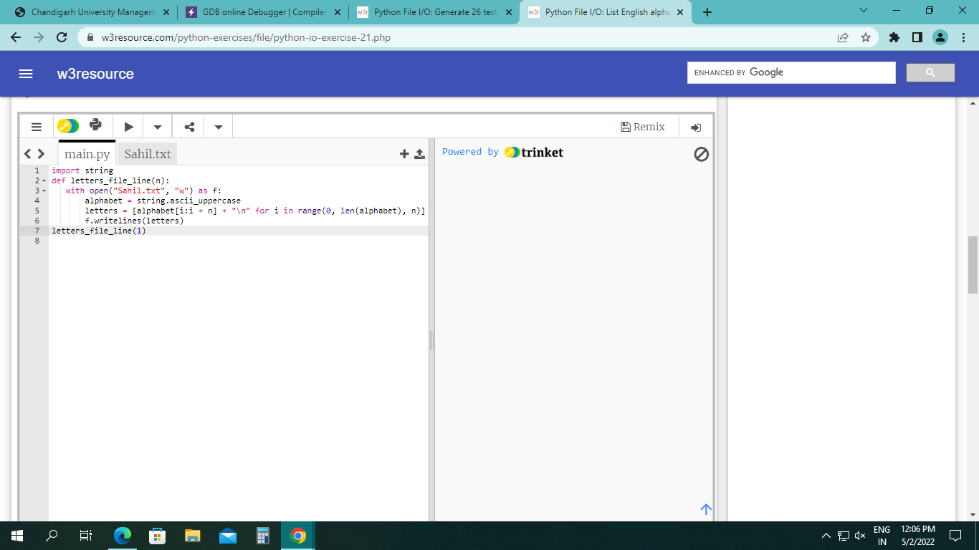

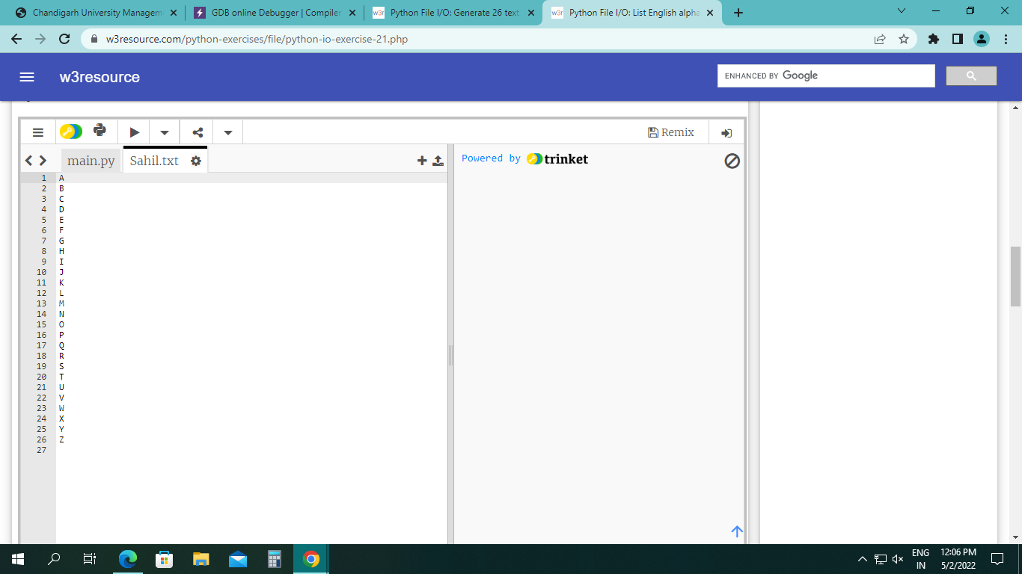

* Write a Python program to read a random line from a file.

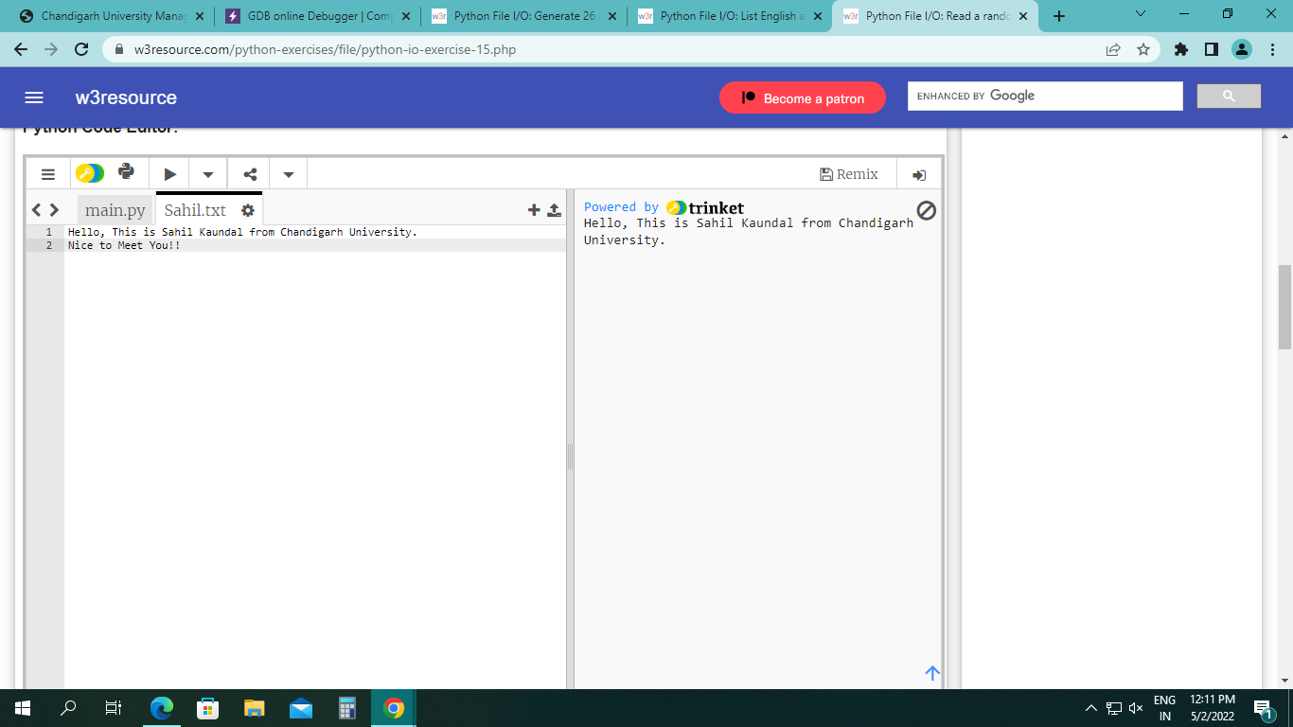

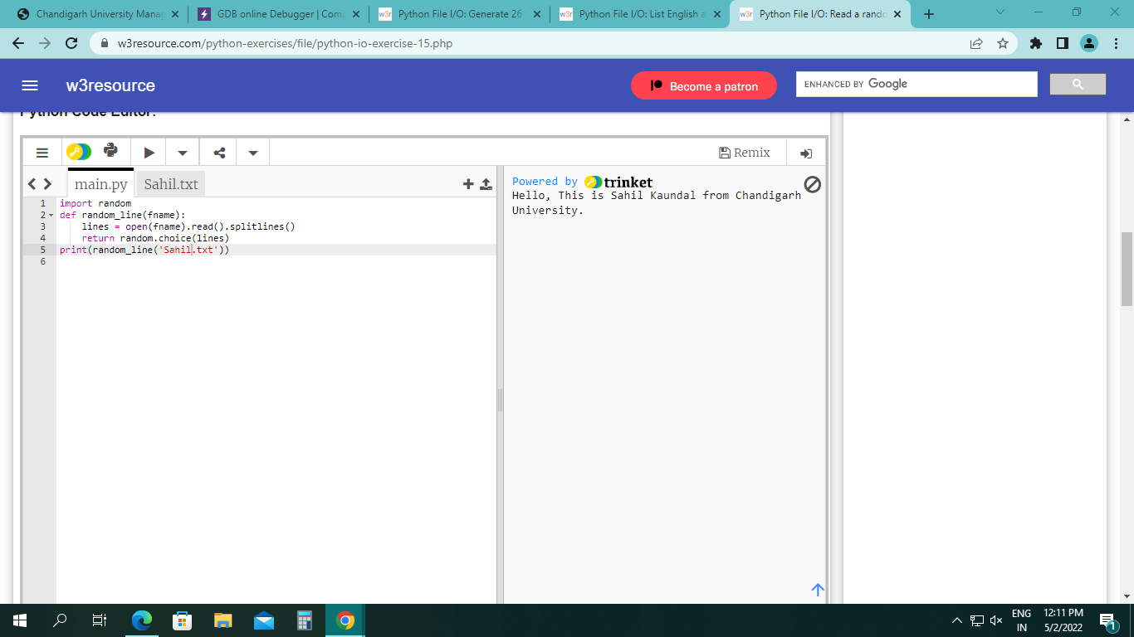

* Write a Python program to count the frequency of words in a file.

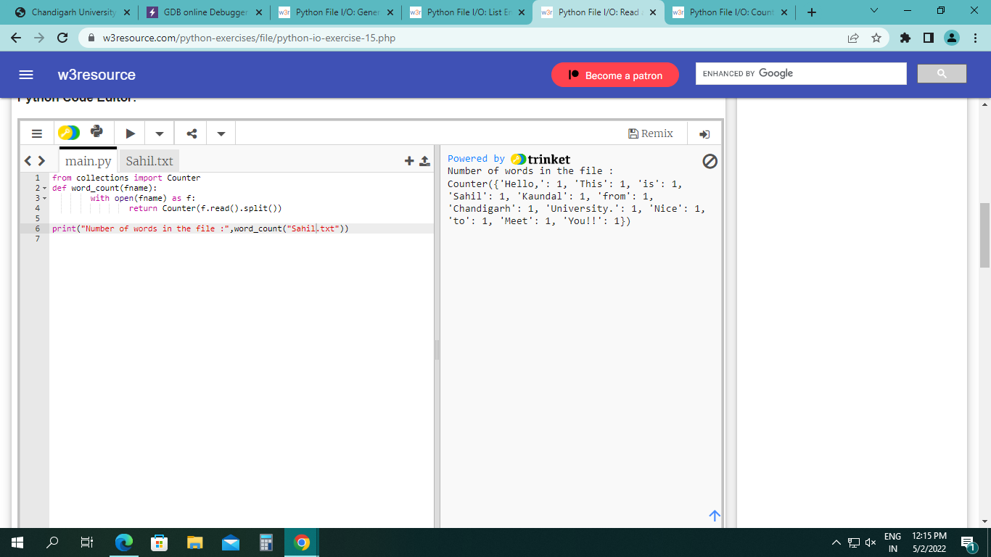

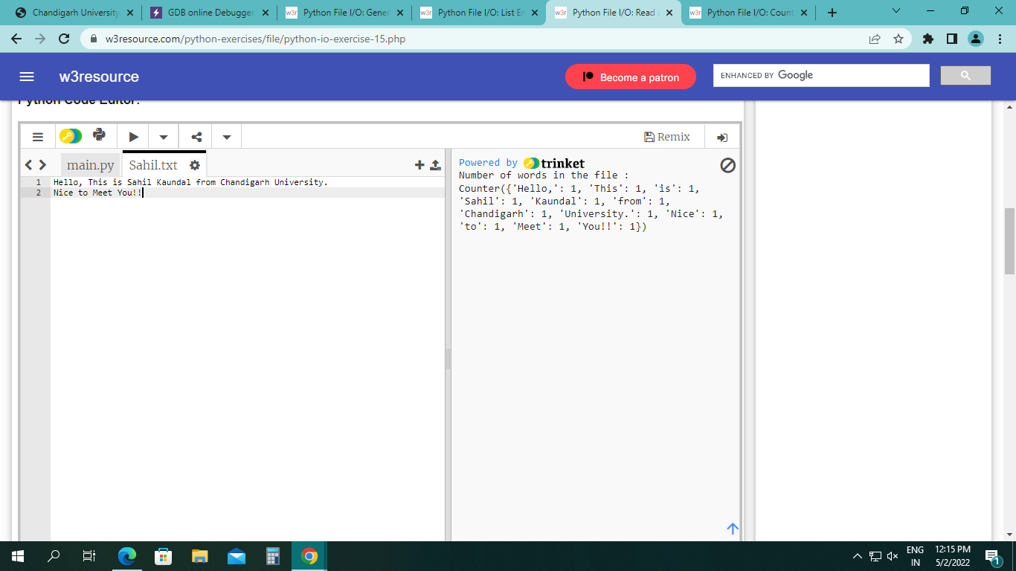

* Write a Python program to copy the contents of a file to another file.

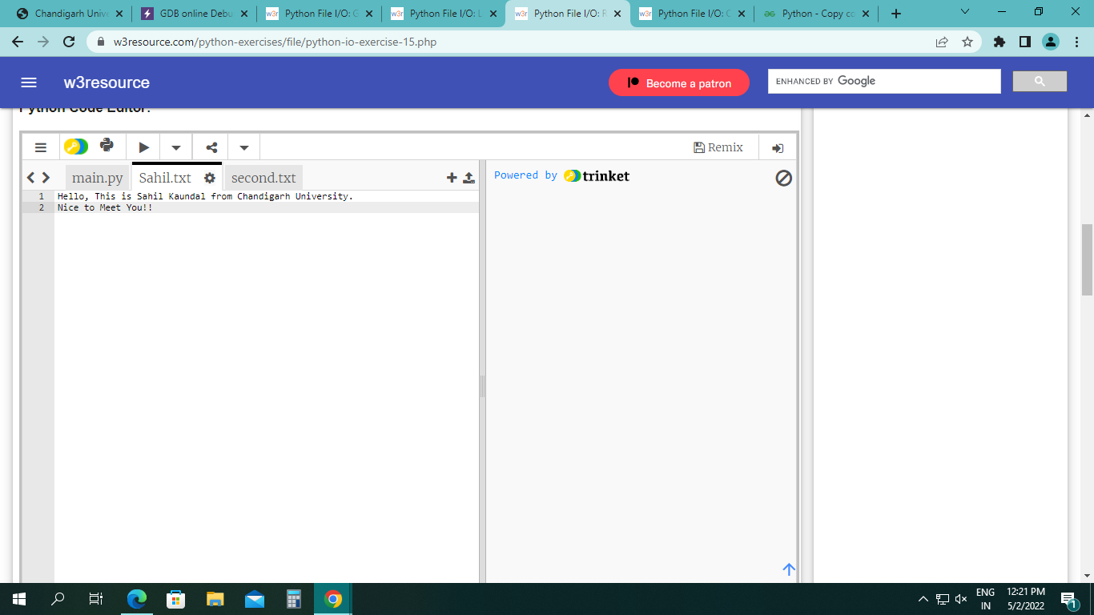

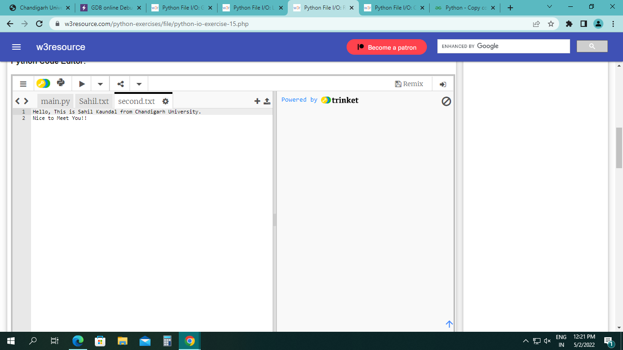

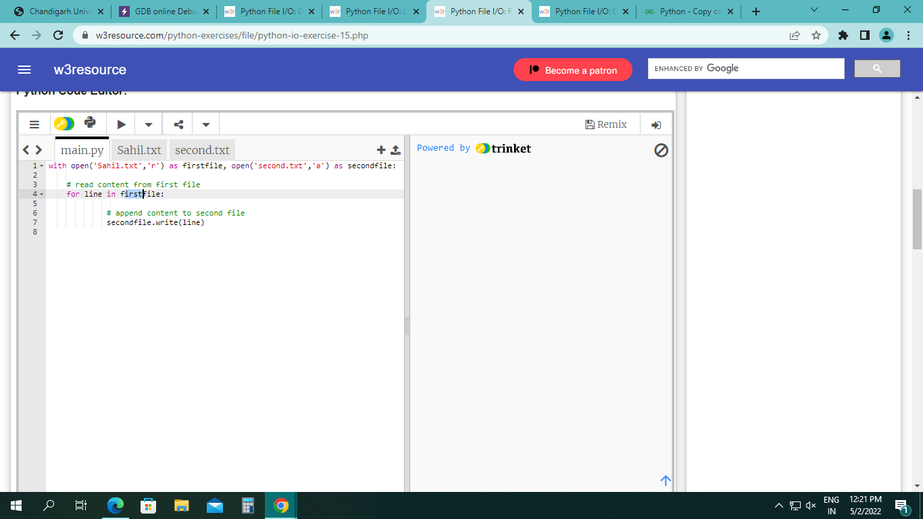

Learning outcomes (What I have learnt):

* Python program to generate 26 text files named A.txt, B.txt, and so on up to Z.txt.
* Python program to create a file where all letters of English alphabet are listed by specified number of letters on each line.
* Python program to read a random line from a file.
* Python program to count the frequency of words in a file.
* Python program to copy the contents of a file to another file.

Evaluation Grid (To be created as per the SOP and Assessment guidelines by the faculty):



|  |  |  |  |
| --- | --- | --- | --- |
| Sr. No. | Parameters | Marks Obtained | Maximum Marks |
| 1. |  |  |  |
| 2. |  |  |  |
| 3. |  |  |  |